Student Name: [NAVEEN.J]

Register Number: [422223243038]

Institution: [SURYA GROUP OF INSTITUTIONS]

Department: [B.TECH(AI&DS)]

Date of Submission: May 8, 2025

GithubRepositoryLink: <https://github.com/naveen10102005/Naveen-NM>

**Fake News Detection**

**1. Problem Statement**

The proliferation of fake news has become a significant societal problem, with the potential to:

* Undermine public trust: False information can erode trust in traditional media, institutions, and even scientific consensus.
* Influence public opinion: Fake news can manipulate people's beliefs and attitudes on important social and political issues.
* Disrupt democratic processes: The spread of misinformation can interfere with elections and other democratic processes.
* Cause real-world harm: In some cases, fake news can incite violence or lead to dangerous behaviors.

Therefore, there is a critical need for effective tools and techniques to detect and combat fake news.

**2. Project Objectives**

This project aims to develop a system that can accurately detect fake news articles. The key objectives include:

* Data Collection and Preparation: Gather a diverse and reliable dataset of both real and fake news articles.
* Feature Extraction: Identify and extract relevant features from the text of the articles, such as linguistic patterns, stylistic elements, and source information.
* Model Development: Build and train machine learning models to classify news articles as either real or fake.
* Performance Evaluation: Evaluate the performance of the models using appropriate metrics, such as accuracy, precision, recall, and F1-score.
* Visualization: Create visualizations to help understand the model's performance and the characteristics of fake news.
* Insight Generation: Provide insights into the key factors that distinguish fake news from real news.

**3. Flowchart of the Project Workflow**

Here's a flowchart illustrating the typical workflow of a fake news detection project:

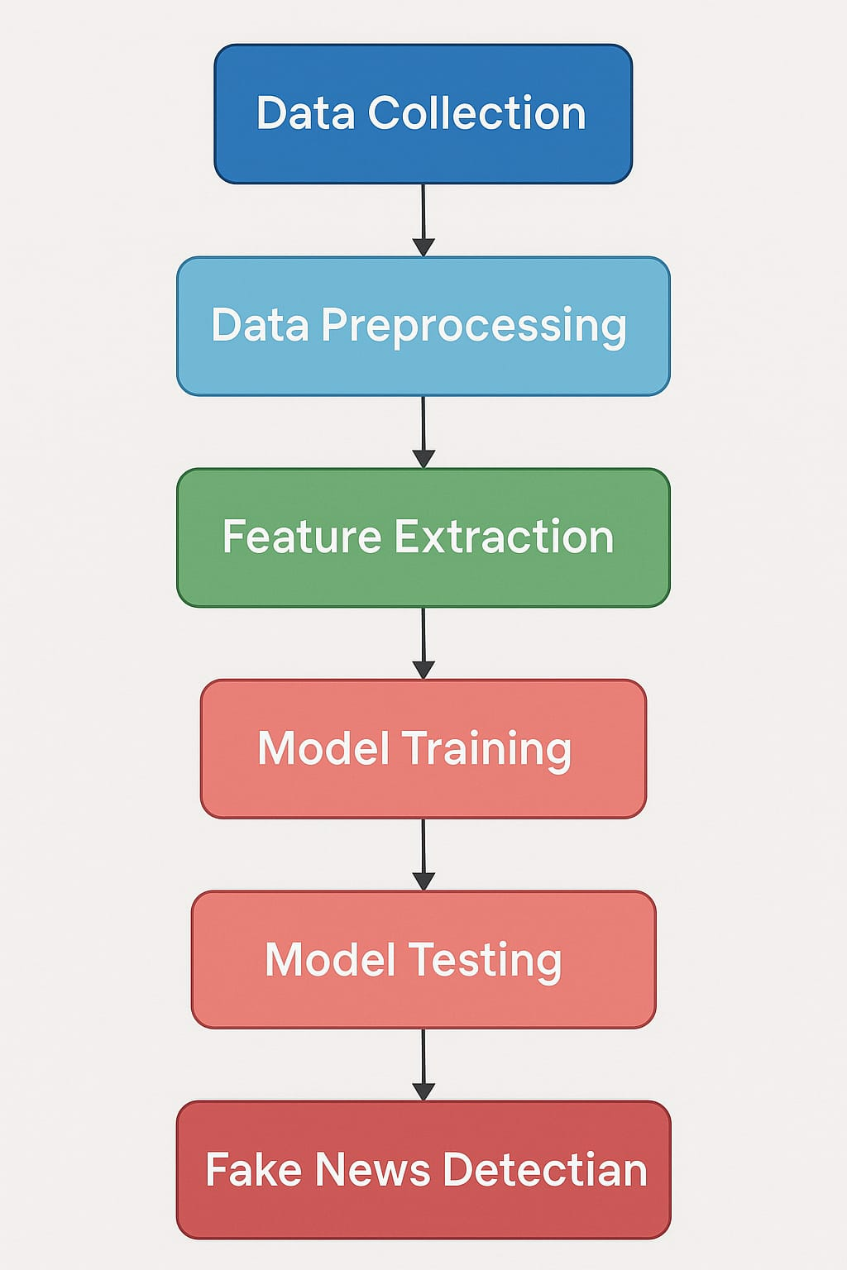[Image of a flowchart for a fake news detection project. The flowchart should include the following steps:

1. Data Collection: Gathering news articles from various sources (real and fake).
2. Data Preprocessing: Cleaning and preparing the text data (removing noise, tokenization, etc.).
3. Feature Extraction: Extracting relevant features from the text (e.g., TF-IDF, word embeddings).
4. Model Selection: Choosing appropriate machine learning models (e.g., Naive Bayes, Logistic Regression, BERT).
5. Model Training: Training the selected model on the labeled data.
6. Model Evaluation: Assessing the model's performance using metrics like accuracy, precision, and recall.
7. Result Visualization: Displaying the results in a clear and understandable format (e.g., charts, graphs).
8. Deployment (Optional): Implementing the model in a real-world application.]

**4. Data Description**

The dataset for this project will consist of a collection of news articles labeled as either "real" or "fake." The data may come from various sources, including:

* Reliable news sources: Reputable news organizations with a history of accurate reporting.
* Fact-checking websites: Websites that specialize in verifying the accuracy of news articles.
* Datasets from previous research: Existing datasets of real and fake news articles.
* Social media: Posts and articles from platforms like Twitter and Facebook (with careful consideration of source reliability).

The dataset should be balanced, with a roughly equal number of real and fake news articles, and diverse, covering a range of topics and writing styles. Each data sample will typically include the following:

* Article title
* Article text
* Source of the article
* Date of publication
* Label (real or fake)

**5. Data Preprocessing**

The text data will need to be preprocessed to make it suitable for machine learning. This may involve the following steps:

* Cleaning: Removing irrelevant characters, HTML tags, and special symbols.
* Tokenization: Splitting the text into individual words or tokens.
* Stop word removal: Removing common words that do not carry significant meaning (e.g., "the," "is," "and").
* Stemming/Lemmatization: Reducing words to their root form (e.g., "running" to "run").
* Lowercasing: Converting all text to lowercase.

**6. Exploratory Data Analysis (EDA)**

EDA will be performed to gain insights into the characteristics of the data and identify potential differences between real and fake news. This may include:

* Descriptive statistics:Analyzing the length of articles, distribution of words, and other basic statistics.
* Word frequency analysis: Identifying the most common words in real and fake news articles.
* Visualization: Creating charts and graphs to illustrate the data, such as word clouds, histograms, and box plots.
* Analysis of source credibility: Examining the sources of the articles and their reputation.

**7. Feature Engineering**

Feature engineering involves creating new features from the raw data that may be more informative for the machine learning models. Potential features include:

* Text-based features:
  + TF-IDF (Term Frequency-Inverse Document Frequency) scores
  + Bag-of-words representation
  + N-gram features
  + Readability scores (e.g., Flesch Reading Ease)
  + Sentiment analysis scores
  + Linguistic features (e.g., use of pronouns, modal verbs)
* Source-based features:
  + Source credibility score
  + Domain name information
* Stylistic features:
  + Use of capitalization, punctuation, and exclamation marks
  + Presence of clickbait phrases
* Network-based features: (If social media data is included)
  + Number of shares, likes, and comments
  + User credibility scores

**8. Model Building**

Several machine learning models can be used for fake news detection. The choice of model will depend on the nature of the data and the desired performance. Some common options include:

* Traditional Machine Learning Models:
  + Naive Bayes
  + Logistic Regression
  + Support Vector Machines (SVM)
  + Random Forest
  + Gradient Boosting Machines (e.g., XGBoost, LightGBM)
* Deep Learning Models:
  + Recurrent Neural Networks (RNNs), such as LSTMs or GRUs
  + Convolutional Neural Networks (CNNs)
  + Transformer-based models, such as BERT, RoBERTa, or DistilBERT

The data will be split into training, validation, and test sets. The training set will be used to train the models, the validation set will be used to tune hyperparameters, and the test set will be used to evaluate the final performance of the models.

**9. Visualization of Results & Model Insights**

The results of the model will be visualized to provide a clear understanding of its performance. This may include:

* Confusion matrices: To show the number of correct and incorrect classifications.
* ROC curves and AUC scores: To evaluate the model's ability to distinguish between real and fake news.
* Precision-recall curves: To assess the trade-off between precision and recall.
* Feature importance plots: To show which features are most important for the model's predictions.

In addition to visualizing the results, the project will also aim to provide insights into the characteristics of fake news. This may involve:

* Analyzing the most important features identified by the model.
* Comparing the linguistic patterns and stylistic elements of real and fake news articles.
* Identifying common themes or topics in fake news.

**10. Tools and Technologies Used**

The project will utilize a variety of tools and technologies, including:

* Programming languages: Python
* Machine learning libraries:scikit-learn, TensorFlow, PyTorch, transformers
* Data processing and analysis libraries: pandas, NumPy
* Natural language processing libraries: NLTK, spaCy
* Visualization libraries:matplotlib, seaborn, plotly
* Other tools:Jupyter Notebooks, Git

**11. Team Members and Contributions**

* Team Member 1:[NAVEEN.J]
  + Contributions: Data collection, data preprocessing, feature engineering.
* Team Member 2: [M.MATHESWARAN]
  + Contributions: Model building, training.
* Team Member 3:[D.MAMALAIVASAN]
  + Contributions: Visualization, report writing.
  + Team Member 4:[M.MOHAMMED FAHIM]
  + Contributions:project management,evaluation.